UConn Pasture & Soil Health Series
Webinar Two: Soil, Plant, Animal Interactions
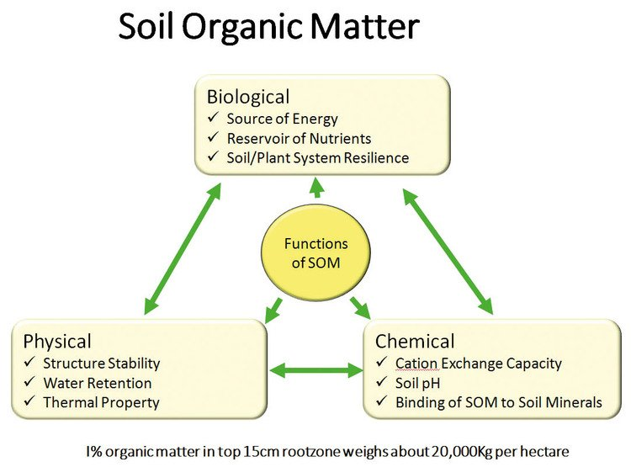
Breakout Group One
Step One:
1. What management practices of soil can increase or decrease SOM?

2. What management practices of forage can increase or decrease SOM?

3. What management practices of animals can increase or decrease SOM?

Step Two:
Choose up to two management practices to dive into. What are the interactions between all three: plant, animal, soil? What other part of the system benefits? What other part of the system might be harmed?

Practice:
Animal:
Soil:
Plant:

Practice:
Animal:
Soil:
Plant:

Step Three:
Prior to discussion with the group, jot down your ideas on this worksheet on the following questions:
1. How much SOM is “good”? What does “good” mean?

2. What is a reasonable percentage of SOM to build in a year? For example, can you increase SOM by 0.01%, 0.01%, 1%, 5%, more, less, etc. in one season?

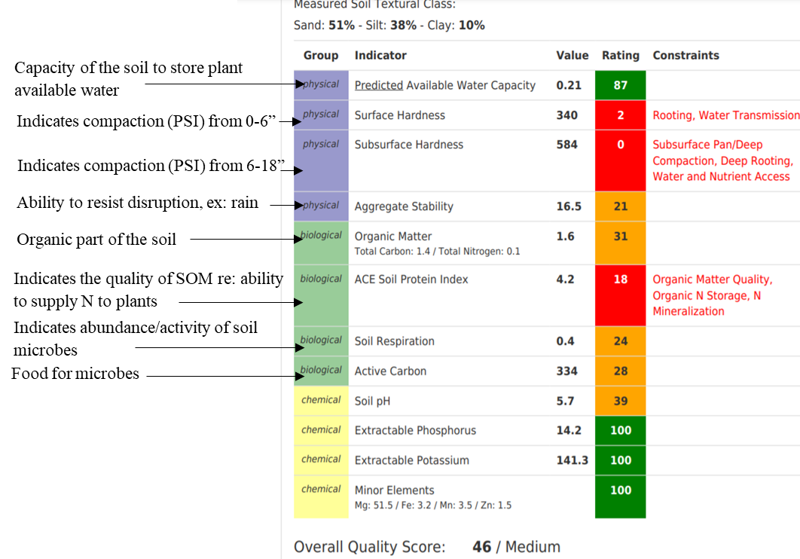
Breakout Group Two
Step One:
Discussion with group on soil test interpretation. Take notes here as desired:

Step Two:
What management practices of the soil, the animals, or the plants can help change these conditions? There are many conditions to pick from! You can focus on an overall soil health improvement, or zero in on a particular topic of interest or concern from this example test.
1. Soil Management:

2. Plant Management:

3. Animal Management:

When we think of the interactions between plants, animals, and soil, what are the potential tradeoffs for each management practice? Will all three parts of your system benefit equally? Will you prioritize one part of your system over another? Choose up to two practices to dive into.
Practice:
Animal:
Soil:
Plant:

Practice:
Animal:
Soil:
Plant:

Step Three
What goals might you set for this field, keeping soil health in mind?

What risks are you concerned about while you improve your soil health in this field?

Will the management practices you proposed in step two addresses these risks in a timely manner, or should further measures be considered during the transition period?

